Our Peeps
These are a few of our favorite things… and people. Check them out!

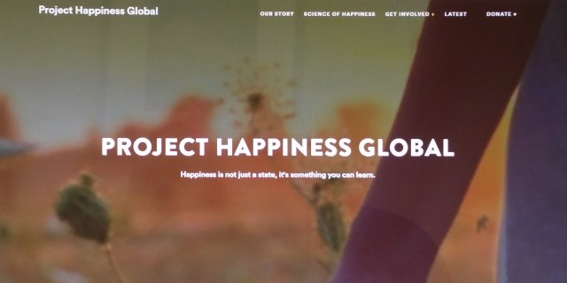
Project Happiness Global
Happiness is not just a state, it’s something you can learn.
[link: www.projecthappiness.org]

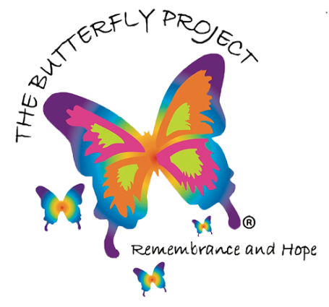
The Butterfly Project
One butterfly painted for every child lost in the Holocaust.
[link: https://thebutterflyprojectnow.org/]
Thrive Global
Founded by Arianna Huffington, Thrive Global’s mission is to end the stress and burnout epidemic by offering companies and individuals sustainable, science-based solutions to enhance well-being, performance, and purpose and create a healthier relationship with technology.

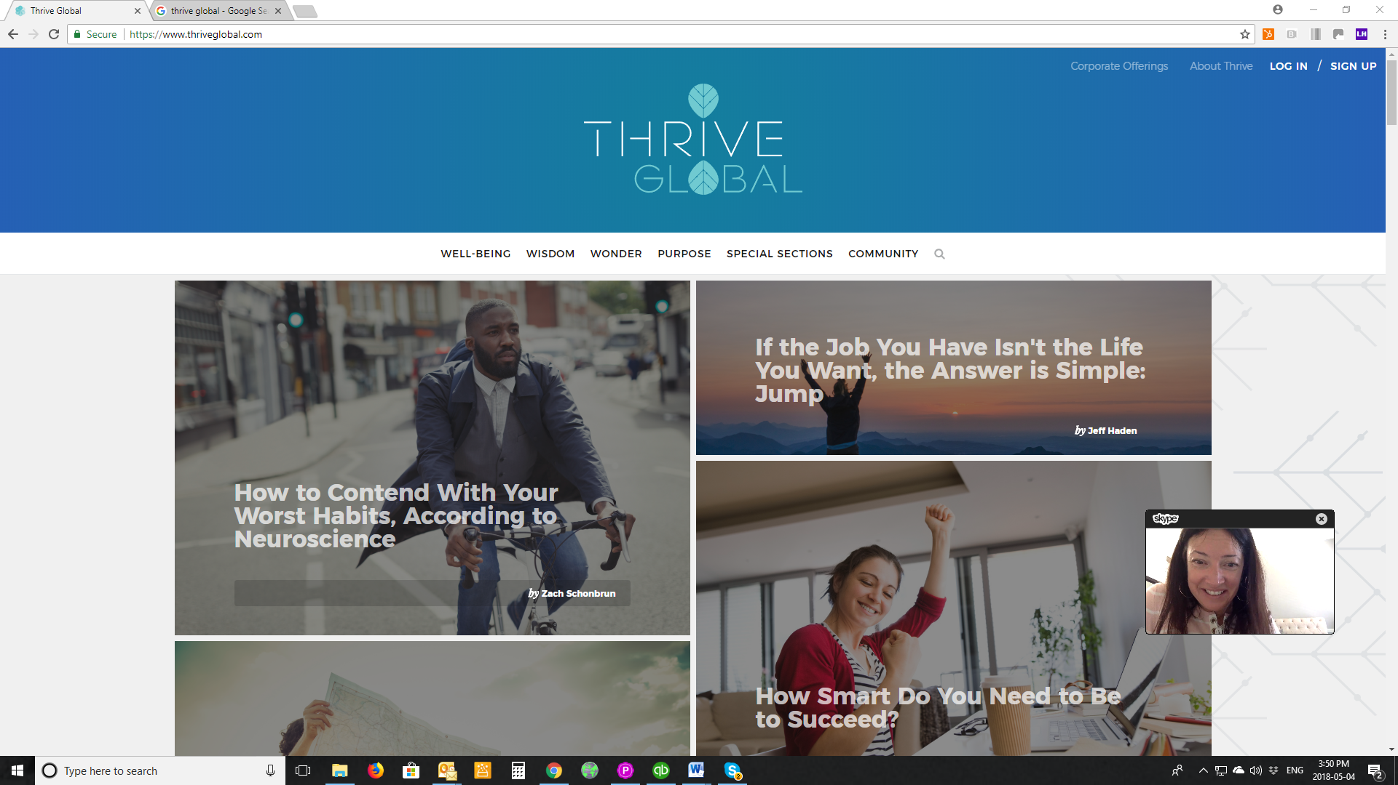


Paula Yoga
One of our wise blog contributors and an awesome yoga instructor to boot!

[link: paulayoga.ca]

Conscious Insight
Discover your inner wisdom.
[link: www.consciousinsight.com]

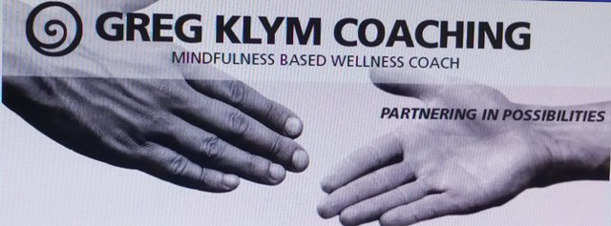

[link: http://www.amandamariemasters.com/]
[link: https://www.facebook.com/gregklymcoaching/]

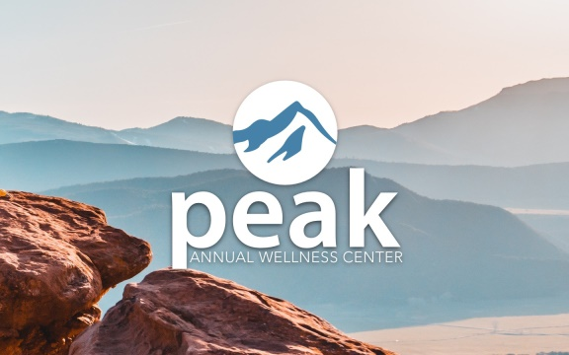
Peak Annual Wellness Center

Most seniors are left uninformed about their healthcare benefits, making them vulnerable to illness and accidents. Peak Annual Wellness Center fills this gap to help seniors regain control of their health.
[link: peakawc.com]


Berlin featuring Terri Nunn
One of the greatest synth electro-pop bands of all time!
[link: http://www.berlinpage.com/]

